Task 2. Vocabularium architecturae aedificatoriae
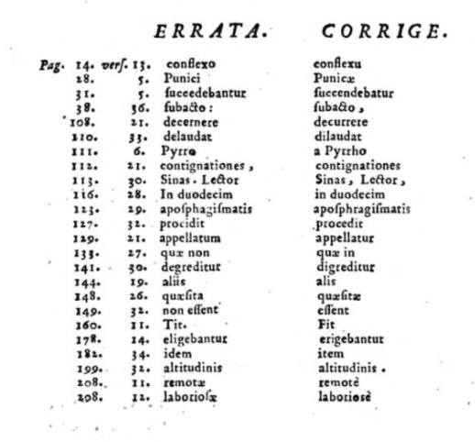

I chose the last page of this book because it includes the correction in hindsight. I find that very interesting and great, because in our age if an error occurs in the book, we just print a new one and back then when all this was written by hand, every book was something special and precious. It can be found on page 264 in the online book.

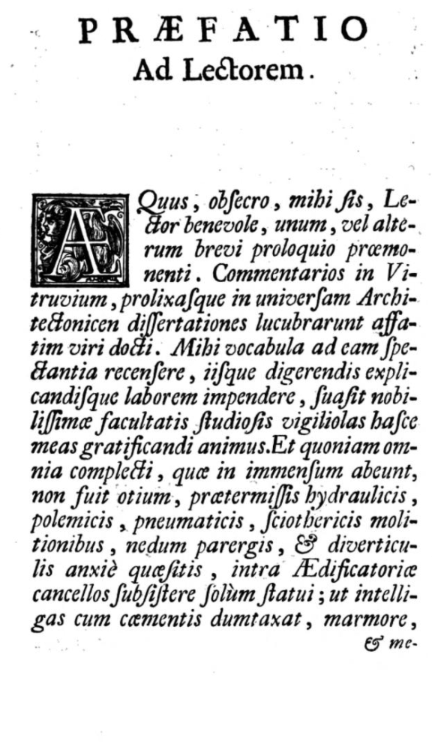

The so-called foreword to the reader can be found on page 8 of the online book. Which is important in every book.

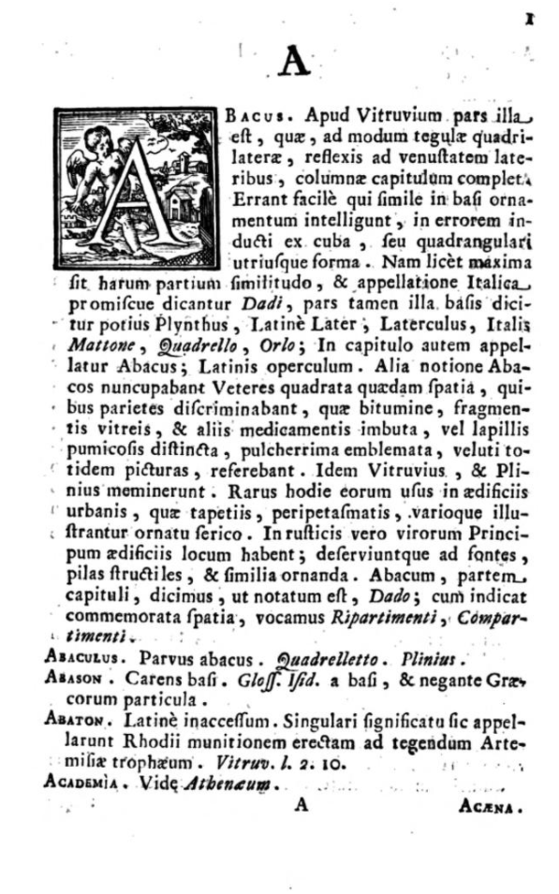

The vocabulary begins on the 12th page of the online book, or on the 1st page of the book. I always like the initial that you find in every section of the letter.

