Friends with an old book; The City and Country Builder's and Workman's Treasury of Designs

3.

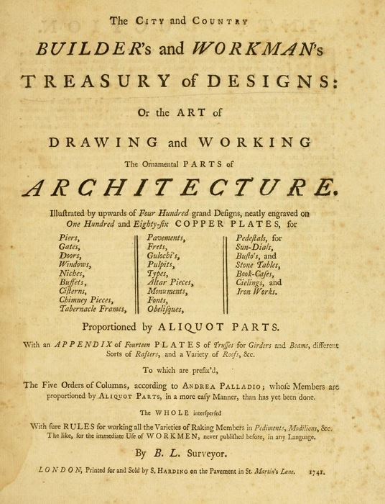

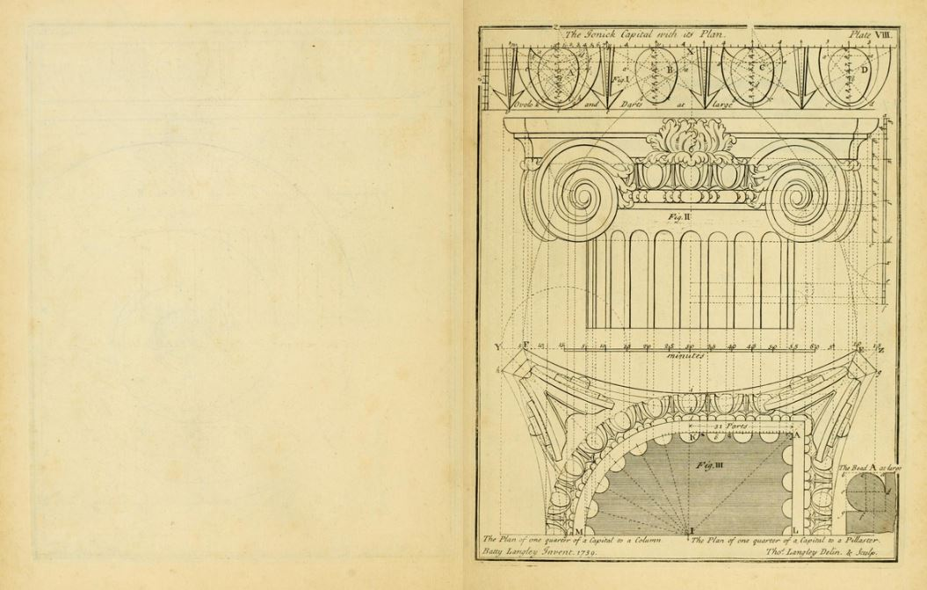

Hannah Schenkel, Leia Steiner & Yamuna Parmar

